EXP NO:2(A)-GENERATION AND ANALYSIS OF FREQUENCY MODULATED
Objective 1: To generate a Frequency Modulated (FM) signal using MATLAB by varying the
frequency of a high-frequency carrier in accordance with the amplitude of the message signal
and to observe the resulting waveform in the time domain.
PROGRAM (MATLAB CODE)
clc;
clear;
close all;
Am=1;
Ac=1;
fm=15;
fc=60;
beta=5;
kp=10;
fs=1000;
t=0:1/fs:1;
m = Am*cos(2*pi*fm*t); % Message signal
c = Ac*cos(2*pi*fc*t); % Carrier signal
fm_sig = Ac*cos(2*pi*fc*t + beta*sin(2*pi*fm*t)); % FM
subplot(4,1,1), plot(t,m), title('Message Signal')
subplot(4,1,2), plot(t,c), title('Carrier Signal')
subplot(4,1,3), plot(t,fm_sig), title('FM Signal')
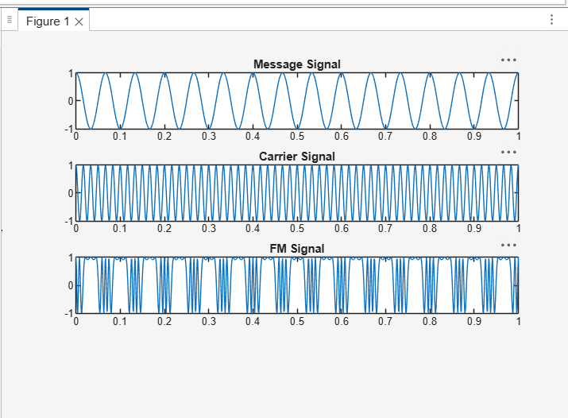
Result:
The Frequency Modulated (FM) signal was successfully generated using MATLAB, and
the time-domain waveforms of the message signal, carrier signal, and FM signal were observed and analyzed.

Objective 2: To analyze the frequency spectrum of the generated FM signal using FFT and
identify the carrier component, sideband frequencies, and the bandwidth of the FM signal based
on Carson's rule
PROGRAM (MATLAB CODE)
% Calculation and Verification of Frequency Deviation
% and Modulation Index of FM Signals
clc;
clear;
close all;
%% Input Parameters
Am = 2; % Message signal amplitude
fm = 500; % Message frequency (Hz)
Ac = 4; % Carrier amplitude
fc = 40000; % Carrier frequency (Hz)
kf = 1000; % Frequency sensitivity (Hz/V)
fs = 500000; % Sampling frequency (Hz)
T = 0.02; % Simulation duration (s)
t = 0:1/fs:T;
%% Message Signal
m = Am*cos(2*pi*fm*t);
%% Frequency Deviation Calculation
delta_f = kf * Am;
%% Modulation Index Calculation
beta = delta_f/fm;
%% FM Signal Generation
fm_signal = Ac*cos(2*pi*fc*t + beta*sin(2*pi*fm*t));
%% Plot Message Signal
figure;
subplot(2,1,1);
plot(t,m,'LineWidth',1.5);
title('Message Signal');
xlabel('Time (s)');
ylabel('Amplitude');
grid on;
%% Plot FM Signal
subplot(2,1,2);
plot(t,fm_signal,'LineWidth',1.5);
title('Frequency Modulated Signal');
xlabel('Time (s)');
ylabel('Amplitude');
grid on;
%% Spectrum Analysis
N = length(fm_signal);
FM_fft = fftshift(abs(fft(fm_signal))/N);
f = (-N/2:N/2-1)*(fs/N);
figure;
plot(f,FM_fft,'LineWidth',1.5);
title('FM Signal Spectrum');
xlabel('Frequency (Hz)');
ylabel('Magnitude');
grid on;
xlim([fc-10000 fc+10000]);
%% Display Results
fprintf('\nFM SIGNAL PARAMETERS\n');
fprintf('---------------------------\n');
fprintf('Carrier Frequency = %.0f Hz\n',fc);
fprintf('Message Frequency = %.0f Hz\n',fm);
fprintf('Message Amplitude = %.2f V\n',Am);
fprintf('Frequency Sensitivity = %.0f Hz/V\n',kf);
fprintf('\nCALCULATED VALUES\n');
fprintf('---------------------------\n');
fprintf('Frequency Deviation (Δf) = %.0f Hz\n',delta_f);
fprintf('Modulation Index (β) = %.2f\n',beta);
%% Carson's Rule Bandwidth
BW = 2*(delta_f + fm);
fprintf('Bandwidth (Carson Rule) = %.0f Hz\n',BW);
OUTPUT:
FM SIGNAL PARAMETERS
---------------------------
Carrier Frequency = 40000 Hz
Message Frequency = 500 Hz
Message Amplitude = 4.00 V
Frequency Sensitivity = 1000 Hz/V
CALCULATED VALUES
---------------------------
Frequency Deviation (Δf) = 4000 Hz
Modulation Index (β) = 8.00
Bandwidth (Carson Rule) = 9000 Hz
>>

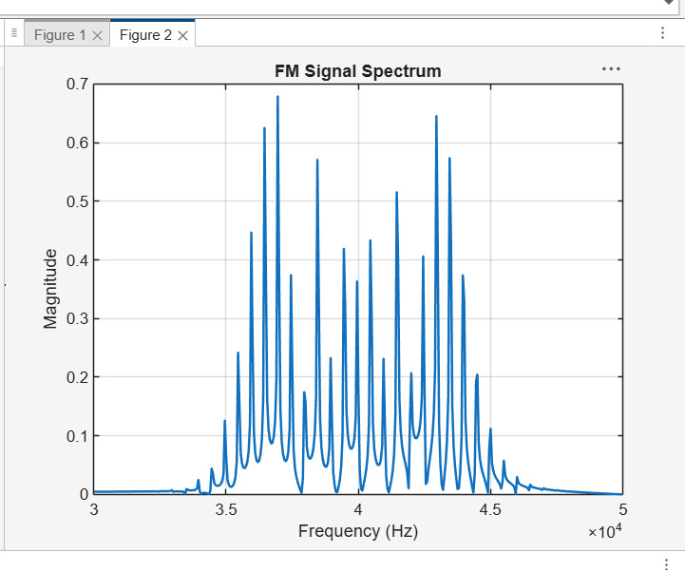
Result
i) The time-domain waveform was observed, and the frequency spectrum obtained using FFT has
been plotted.
ii) Also, calculated the frequency deviation and bandwidth using Carson’s rule.

EXP-2(B) CALCULATION AND VERIFICATION OF FREQUENCY DEVIATION AND MODULATION INDEX OF FM SIGNALS
Objectives:
To generate a Frequency Modulated (FM) signal in MATLAB using specified message and
carrier signal parameters, and to determine the frequency deviation and modulation index of the
FM signal while analyzing the relationship between frequency deviation, message frequency,
and modulation index.
PROGRAM (MATLAB CODE)
% Calculation and Verification of Frequency Deviation
% and Modulation Index of FM Signal
clc;
clear;
close all;
%% Message Signal Parameters
Am = 2; % Message amplitude (V)
fm = 500; % Message frequency (Hz)
%% Carrier Signal Parameters
Ac = 18; % Carrier amplitude (V)
fc = 20000; % Carrier frequency (Hz)
%% FM Parameters
kf = 250; % Frequency sensitivity (Hz/V)
fs = 100000; % Sampling frequency (Hz)
T = 0.01; % Simulation duration (s)
%% Time Vector
t = 0:1/fs:T;
%% Message Signal
m = Am*cos(2*pi*fm*t);
%% Frequency Deviation
delta_f = kf*Am;
%% Modulation Index
beta = delta_f/fm;
%% FM Signal
fm_signal = Ac*cos(2*pi*fc*t + beta*sin(2*pi*fm*t));
%% Display Parameters
fprintf('Carrier Frequency (fc) = %.0f Hz\n',fc);
fprintf('Message Frequency (fm) = %.0f Hz\n',fm);
fprintf('Message Amplitude (Am) = %.0f V\n',Am);
fprintf('Frequency Sensitivity (kf) = %.0f Hz/V\n',kf);
fprintf('\nFrequency Deviation (Delta f) = %.2f Hz\n',delta_f);
fprintf('Modulation Index (Beta) = %.2f\n',beta);
%% Verification
beta_verify = delta_f/fm;
fprintf('Verified Modulation Index = %.2f\n',beta_verify);
%% Verification Check
tolerance = 1e-6;
if abs(beta - beta_verify) < tolerance
fprintf('\nVerification Successful\n');
else
fprintf('\nVerification Failed\n');
end
%% Plotting
figure;
subplot(2,1,1);
plot(t,m,'LineWidth',1.5);
grid on;
title('Message Signal');
xlabel('Time (s)');
ylabel('Amplitude (V)');
subplot(2,1,2);
plot(t,fm_signal,'LineWidth',1);
grid on;
title('FM Signal');
xlabel('Time (s)');
ylabel('Amplitude (V)');
OUTPUT:
Carrier Frequency (fc) = 20000 Hz
Message Frequency (fm) = 500 Hz
Message Amplitude (Am) = 2 V
Frequency Sensitivity (kf) = 250 Hz/V
Frequency Deviation (Delta f) = 500.00 Hz
Modulation Index (Beta) = 1.00
Verified Modulation Index = 1.00
Verification Successful
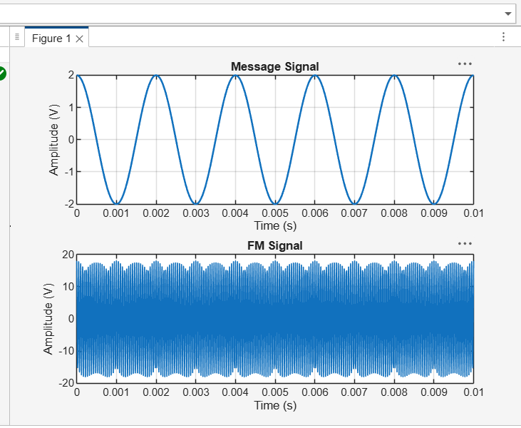
RESULT:
This experiment verifies that the modulation index is equal to the ratio of frequency deviation to message frequency, i.e., β=Δf/f_m.

